Design Thinking

Five stages of design thinking

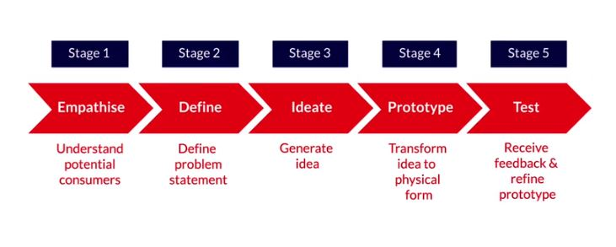

**Empathise**

Empathise is the first and one of the most important stages in Design Thinking. This helps entrepreneurs to understand the experience of users for whom they are developing the product. This is done to understand why people do things in a certain way and use those insights in developing a product.

# Define

Empathise helped you understand the pain points that users face. There would be a lot of insights that you would have gained through observing or talking to your users. The next stage Define helps **process and synthesise findings** that help bring clarity to the design process. The purpose of this stage is to articulate a problem statement that will address the issue that you find most critical and worth solving. Define is basically what, how and why.

In this phase, you understood how to come up with or create a problem statement based on the pain points identified. This will help you in designing solutions while addressing particular issues you are trying to solve.

The pain points that Zomato identified were:

1. Lack of restaurant choice
2. No transparency in delivery time
3. Unreliable delivery
4. Too much time spent in placing an order

# Ideate

Define helped you create a problem statement based on the pain points identified. In the next stage – Ideate - you will work on **creating solutions to address the problem statement**. Here you will develop as many solutions as you can which will eventually help you develop the prototype.

Ideation helps in developing solutions for the defined problem statement. These solutions are best put in the form of sketches where thoughts have been put together. Zomato drafted out the process on how each step would be followed by the user.

# Prototype

Ideate helped you develop various solutions for the problem statement. In order to avoid all the potential solutions created, one must go through a selection process for identifying the best solutions which can be taken forward for prototyping. The resulting prototype would be something users can interact with.

# Test

Prototype & test are two stages which are generally considered together. This is mainly because the feedback of the prototype created in stage 4 is validated in stage 5 which is Test. Ask users to take the product, use it and you make note of the feedback to understand how they interact with the prototype. These insights will help you make iterations and help you make a better product.

Testing is an iterative process where you seek feedback and work towards improving the product. This stage also helps to understand your users better and also clarifies whether you have indeed solved the problem or pain points they were facing.

Zomato tested its product with 10,000 users and observed and recorded how users were using the Zomato app. They made note of the various observations and incorporated the findings into the app.

Some important links

<https://www.forbes.com/sites/lawtonursrey/2014/06/04/14-design-thinking-esque-tips-some-approaches-to-problem-solving-work-better-than-others/?sh=2e499ea51627>

<https://yourstory.com/2015/09/bruce-nussbaum/amp>

<https://yourstory.com/2014/03/design-thinking-entrepreneurs/amp>

* **Empathise**: In this stage, you need to get into the shoes of the consumer and use the emotional language to describe users. This means getting to know them through interviews, observations and learning how they would possibly interact with your product.
* **Define**: In this stage, you need to define the problem which you observed in the previous stage.
* **Ideate**: In this stage, you can explore a wide variety of solutions skipping the obvious ones.
* **Prototype**: In this stage, you transform your idea into a physical form where it can interact with your users. Building a prototype allows you to see how your product might feel in the hands of the intended users.
* **Test**: Now this is where you can put your prototype in front of users, learning how they interact with it, giving you an opportunity to refine the product based on user feedback.